

Symbiosis Institute of Technology, Pune
Faculty of Engineering CSE- Academic Year 2026-27
Java Programming – Lab Batch 2025-29

Lab Assignment No.: 3
Name of Student | Akshit Gawade
PRN No. | 25070122029
Batch | 2025-2029
Class | A1
Academic Year & Semester | Second Year Semester III
Date of Submission | 11/7/26
Title of Assignment: | Develop a Java application demonstrating method overloading and the use of static  variables, methods in class design.
Problem Statement | Develop a Java application demonstrating method overloading and the use of static variables, methods in class design.  Learning Objectives  To implement method overloading and use static variables and methods in Java programs.
Theory | Method overloading allows multiple methods to have the same name with different parameter lists, enabling compile-time  polymorphism. The static keyword is used for variables and methods that belong to the class instead of individual objects.  Static members share common data among all objects and reduce memory usage. These concepts improve code flexibility,  readability, and efficient resource management.
Program Code | 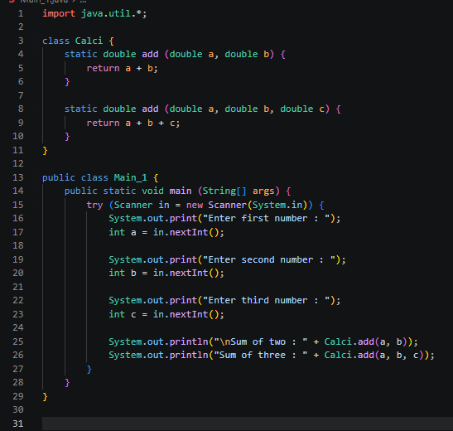  2nd  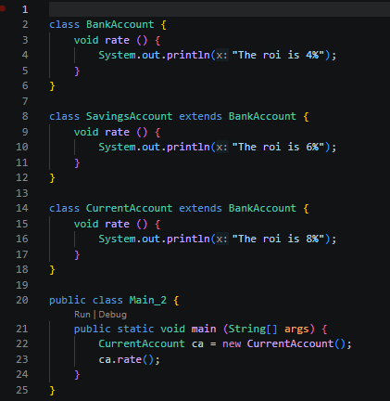

Output Screenshots | 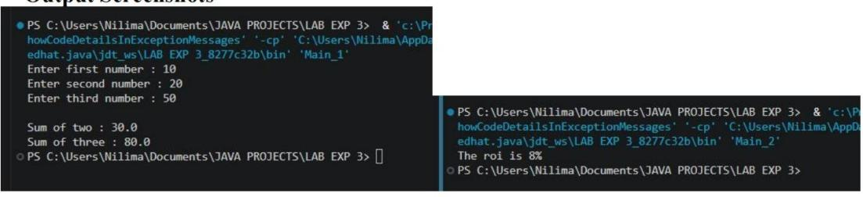
Practice Questions | Q1. Develop a Calculator program using overloaded methods for addition of integers and decimals. Use a static variable to count calculations.  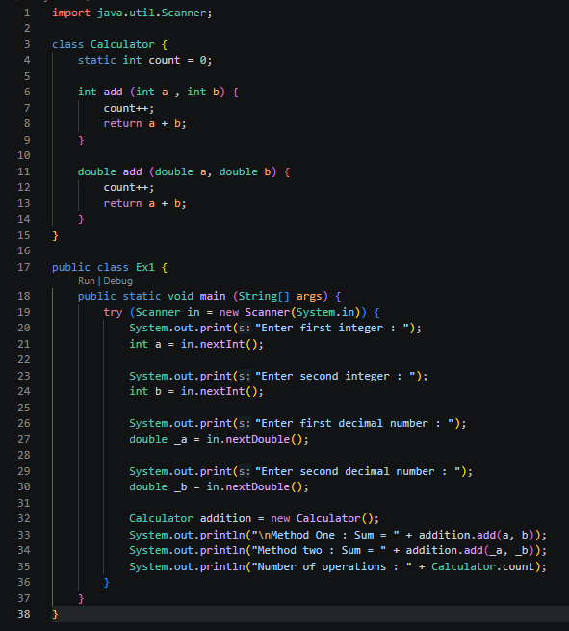  Q2. Develop a Restaurant Billing Application where overloaded methods calculate bills for dine-in, takeaway, anddelivery orders, while static variables track total orders.  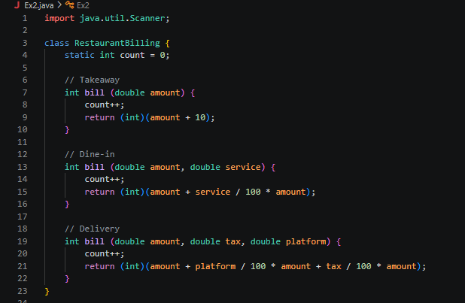  Q3. Method Overriding: A vehicle tracking system needs to calculate the maximum speed of different types of vehicles.  A generic vehicle has a base speed. A car has a higher max speed.  A bike has an even higher max speed.  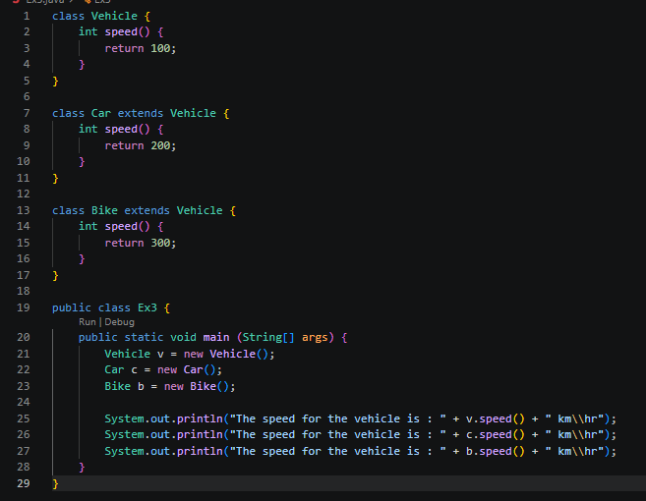  Q4. Method Overloading: Payment Processing System  A company is building a payment gateway that allows users to pay using different methods:  Credit Card (card number & CVV)  Bank Transfer (account number & IFSC code) UPI ID  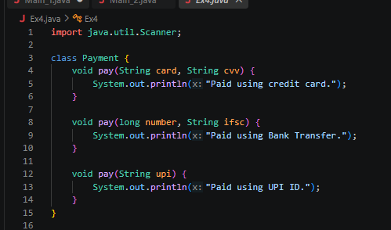  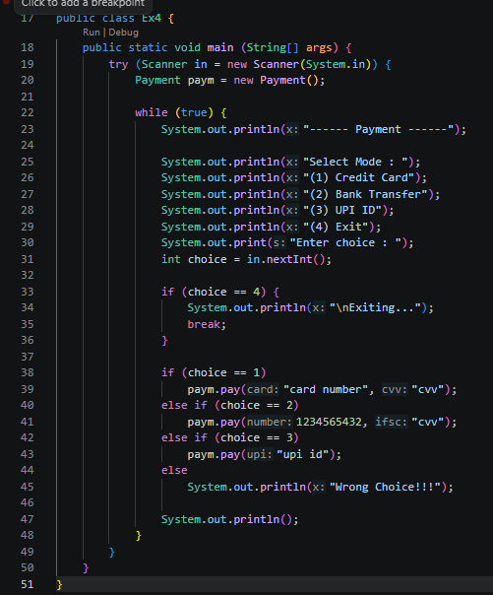
Output Screenshots | Q1:  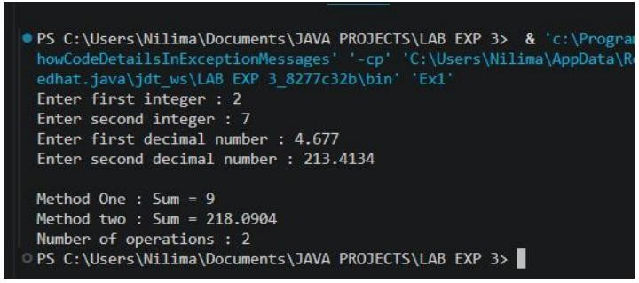

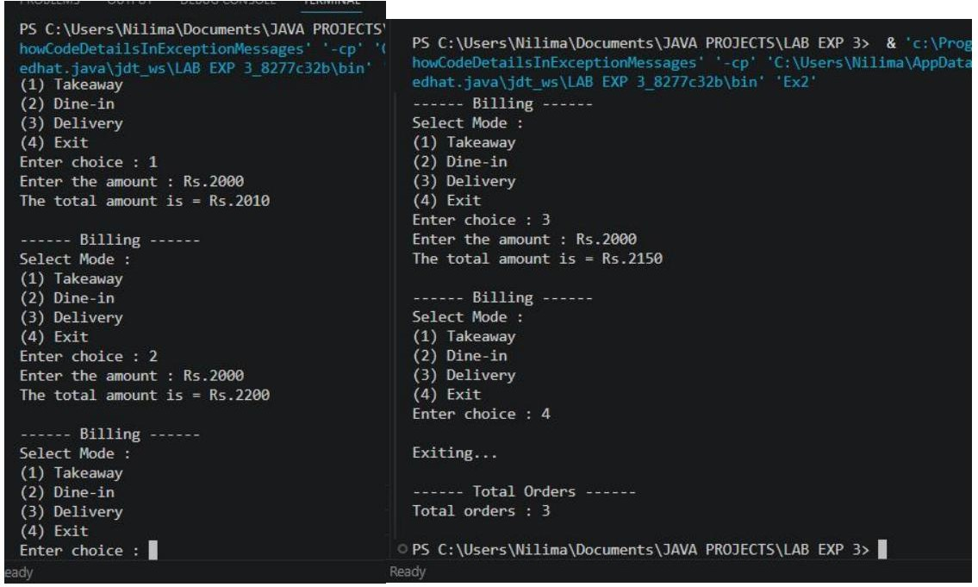
Q2:

Q3:

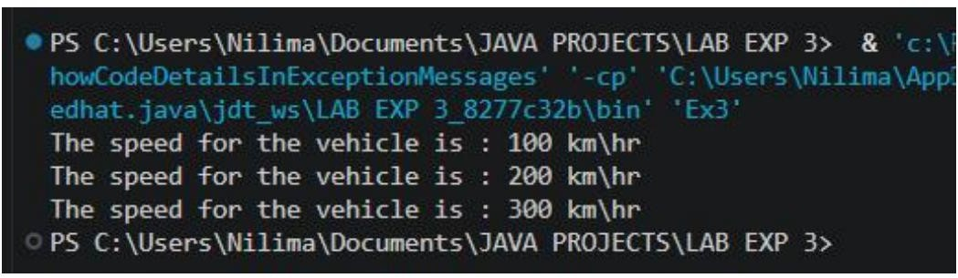
Q4:

 | 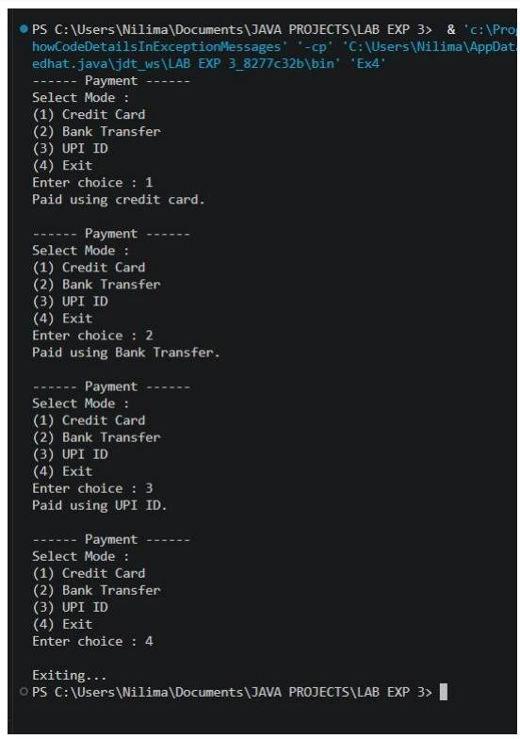
Conclusion | This assignment helped in understanding the concepts of method overloading and static variables and methods in Java. It demonstrated how method overloading enables multiple methods with the same name to perform different tasks based on their parameter lists, improving code flexibility and readability. The use of static variables and methods showed how data and functionality can be shared among all objects of a class, reducing memory usage and simplifying program design.  These concepts are fundamental to object-oriented programming and are widely used in developing efficient, reusable, and well-structured Java application.

